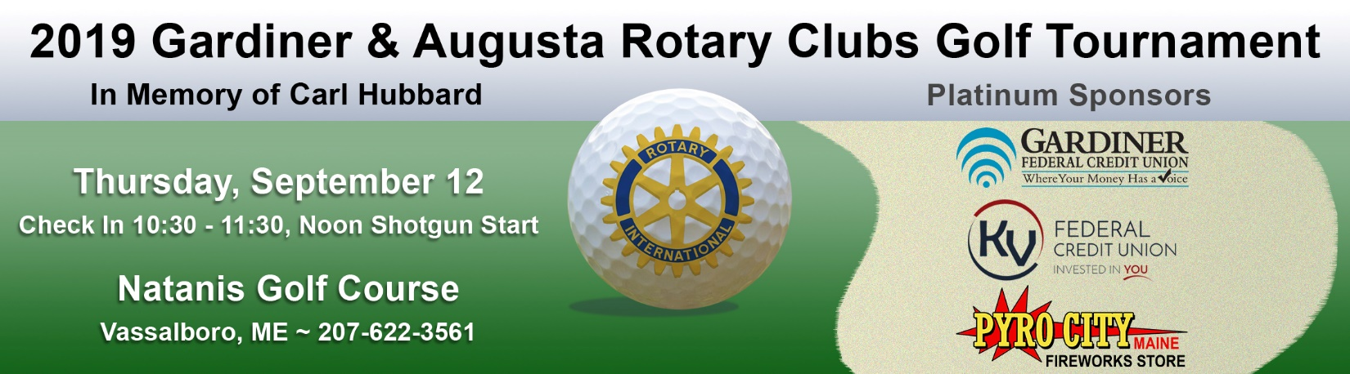
Proceeds support charitable works by the Gardiner & Augusta Rotary Clubs. Thank you for your support.
Sponsorship Opportunities
$1,000 Platinum Level Sponsorship Includes:
- Sponsorship mention on all printed materials at the tournament & on advanced promotional material
- Option to set up a booth at the tournament, for display materials, or to display a banner at check-in
- One foursome in the tournament
- One hole sponsor sign
- Company listing on the Gardiner & Augusta Rotary websites, as a tournament sponsor
- Introduction & special thank you recognition, during awards reception
$500 Gold Level Sponsorship Includes:
- Sponsorship mention on all printed materials at the tournament
- One foursome in the tournament
- One hole sponsor sign
- Company listing on the Gardiner & Augusta Rotary websites, as a tournament sponsor
- Introduction & special thank you recognition, during awards reception
$350 Golf Cart Sponsorship (limit of 2 available) Includes:
- Sponsorship mention on all printed materials at the tournament
- Signs on all golf carts, listing you as cart sponsor
$250 Lunch Sponsorship Includes:
- Sponsorship mention on all printed materials at the tournament
- Signs on the lunch cart(s) listing you as a lunch sponsor
$125 Hole Sponsorship Includes:
- One hole sponsor sign (hole sponsor signs are 16”x12”, with company or individual’s name)
“Fore Any Amount” Sponsorship - Any Donation Amount Welcome
- We are grateful for donations in any amount. If you would like to send a donation, along with your registration.
To sign up a team and/or to become a sponsor, please see next page
Questions, regarding sponsorships or the tournament, may be directed to these Rotarians
Brent Hall 622-5801  bhall@kennebecsavings.bank | Chris Markos 329-3556  cmarkos1@gmail.com | Tracie James 582-2676 x 113  tjames@gardinerfcu.org | Vicki Larrabee 582-2676 x 115  vlarrabee@gardinerfcu.org

